Application for Admission

Wild Calm: Forest Bathing & Restoration Retreat at Pine Cove

Monday, September 7th to Thursday, September 10th, 2026


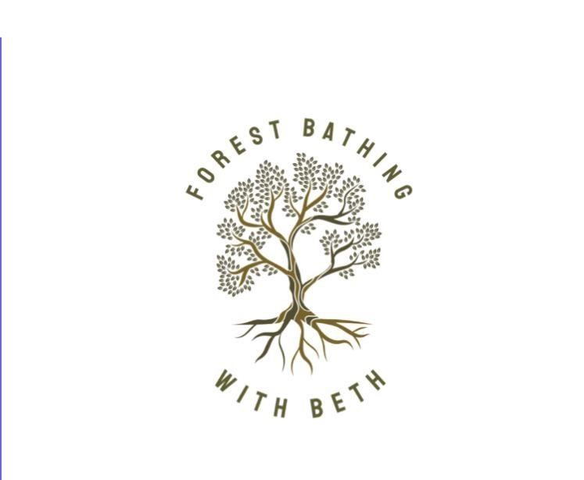
To apply, complete this form and email to info@frenchriver.com For more information, visit www.frenchriver.com

Personal Information
Last Name _____________________ First Name
_________________________ Home address
___________________________________________
City _________________________
Province ____________ Postal Code ________________
Mailing address (if different from above)
_________________________________
City _________________________
Province ____________ Postal Code ____________________ Other (if your address is not in Canada) __________________________________
Telephone number (____) _____-____________
Cell phone number (____) _____-____________
Email __________________________________
Website__________________________________________________
Birthdate ____________ Gender _______
How did you hear about the "Wild Calm: Forest Bathing & Restoration at Pine Cove” Retreat?
__________________________________________________________

Accommodations & Fees:
Please choose one:
Deluxe Private Cottage
Enjoy one of our deluxe cottages all to yourself! Cottage with full kitchen & bathroom Tuition + accommodations for three nights + all meals:
$1853 + gratuities (15%) + HST
Private Bedroom & Shared bathroom
Enjoy your private bedroom, all to yourself, and share a bathroom with
other guests. Tuition + accommodations for three nights + all meals:
$1481 + gratuities (15%) + HST

Do you have food restrictions? If so, please describe:
__________________________________________________________
______________
__________________________________________________________
______________ __________________________________________________________ ______________
Do you have mobility concerns? We will not be walking far (about 1 km in 2 hours) or fast, but there may be some uneven terrain. Hiking poles or use of a staff are welcome._________________________________
Signature ____________________________ Name
____________________________ Date
________________________________
Please submit this form to info@frenchriver.com.

We will make sure that your completed application is reviewed in a timely fashion, and will help you with next steps.
Questions about Forest Bathing may be answered under FAQ’s on my website: forestbathingwithbeth.com
Welcome to the first annual
Wild Calm: Forest Bathing & Restoration Retreat at Pine Cove!
Thanks for stepping into the calm. See you in September.

